|  |  |
| --- | --- |
| **Project Name :** | **Academic Year :** |
| **Subject Name:** | **Semester : Sixth** |

**A STYDY ON**

Study on **Topic Name**

***MICRO PROJECT REPORT***

**Submitted in March 2025 by the group of……3….students**

|  |  |  |  |  |
| --- | --- | --- | --- | --- |
| **Sr. No** | **Roll No (Sem-vi)** | **Full name of Student** | **Enrollment No** | **Seat No (Sem-vi)** |
| 1 |  |  |  |  |
| 2 |  |  |  |  |
| 3 |  |  |  |  |

Under the Guidance of

[ your guide name ]

in

Three Years Diploma Program in Engineering & Technology of Maharashtra State Board of Technical Education, Mumbai (Autonomous)

ISO 9001:2008 (ISO/IEC-27001:2013)

at

[ your college name ]



**MAHARASHTRA STATE BOARD OF TECHNICAL EDUCATION, MUMBAI**

***Certificate***

This is to certify that Mr. /Mrs.

Roll No: of **Sixth Semester**  of **Diploma in Engineering & Technology** at **[ your college name ] ,** has completed the **Micro Project** satisfactorily in Subject **Subject Name** in the academic year 2024-2025 as per the MSBTE prescribed curriculum of I Scheme.

Place: Pune Enrollment No:

Date: / / 2025 Exam Seat No:

# Project Guide Head of the Department Principal

Head of Institute

**INDEX**

|  |  |  |
| --- | --- | --- |
| **Sr.** | **Title** | **Page No .** |
|  | Abstract |  |
| 1. | Introduction |  |
| 2. | Literature Survey |  |
| 3. | System Design |  |
| 4. | Data Flow Diagram |  |
| 5. | Use Case Diagram |  |
| 6. | Testing and Evaluation |  |
| 7. | Conclusions |  |
| 8. | References |  |

**Abstract**

The **Attendance Management System for College** is an Android-based application designed to modernize and simplify the traditional attendance-taking process. In many educational institutions, attendance is still recorded manually using paper registers or spreadsheets, which is **time-consuming, prone to human errors, and inefficient** when it comes to data retrieval and analysis. This project addresses these challenges by providing an **automated, digital solution** that allows teachers to mark attendance quickly and accurately using their mobile devices.

The system is designed to be **user-friendly and efficient**. Teachers can **log in, select a class**, and view a list of students enrolled in that class. With a simple tap, they can **mark students as present or absent**, eliminating the need for paper-based records. Once attendance is recorded, the system **automatically calculates and displays** the total number of students present and absent, providing real-time data without manual counting. The application enhances accuracy and minimizes the chances of miscalculations, ensuring reliable attendance tracking.

This project is developed using **XML for the user interface and Java for backend logic**, ensuring a smooth and responsive user experience. The **backend logic efficiently processes the attendance data**, and the **UI is designed to be clean, intuitive, and easy to navigate** for teachers of all technical backgrounds. The system architecture is built to be **lightweight and efficient**, allowing for seamless operation on Android devices.

The **Attendance Management System** offers several advantages over traditional methods:

* **Efficiency**: Teachers can complete attendance marking in just a few taps, saving valuable classroom time.
* **Accuracy**: Automated calculations reduce human errors in attendance records.
* **Convenience**: The digital format eliminates the need for physical attendance registers.
* **Data Accessibility**: The application can be extended to generate reports and store attendance history for future reference.

This report provides a **detailed overview of the system, including its design, functionality, implementation, testing, and evaluation**. It demonstrates how the Attendance Management System serves as a **practical and effective solution** for improving attendance tracking in colleges, making the process **faster, more accurate, and paperless**.

**Introduction**

#### ****1.1 Overview****

Attendance tracking is a crucial aspect of academic institutions, ensuring that students maintain the required presence in classrooms. Traditionally, attendance is recorded using paper registers or spreadsheets, which can be inefficient, time-consuming, and prone to errors. Manual record-keeping often leads to difficulties in tracking absences, generating reports, and ensuring accuracy. To overcome these challenges, this project presents an **Android-based Attendance Management System** that provides a **digital and automated approach to attendance tracking**.

The proposed system allows teachers to **select a class, mark students as present or absent, and view the total number of students present and absent** in real-time. By leveraging **mobile technology, XML-based UI, and Java for backend processing**, the system offers a seamless and efficient solution that enhances the overall attendance management process.

This project is particularly beneficial for colleges, where large numbers of students need to be tracked efficiently. The system not only eliminates paperwork but also **ensures accuracy and saves time**, making attendance-taking a quick and hassle-free task for teachers.

#### ****1.2 Problem Statement****

The traditional method of recording attendance in colleges involves **manually entering student attendance into registers or spreadsheets**, which presents several challenges:

* **Time-Consuming**: Taking attendance manually can take up a significant portion of class time, especially in large classrooms.
* **Error-Prone**: Teachers may accidentally mark incorrect attendance or miscalculate the number of students present.
* **Difficult to Manage**: Searching for previous records or analyzing attendance trends requires going through multiple registers, which is inconvenient.
* **Paper-Based Records**: Physical registers are prone to damage, loss, or misplacement, leading to potential data loss.
* **Lack of Automation**: Manual methods do not provide automatic attendance summaries or analytics, making report generation difficult.

The **Attendance Management System** aims to solve these issues by **digitizing the process, reducing human errors, and improving the efficiency of attendance tracking**.

#### ****1.3 Objectives****

The primary objectives of the **Attendance Management System for College** are:

1. **To develop an Android-based application** that allows teachers to mark student attendance digitally.
2. **To simplify the process** of selecting a class and marking students as present or absent.
3. **To automate attendance calculations**, displaying the number of students present and absent instantly.
4. **To reduce the dependency on paper-based records**, making attendance data more accessible and manageable.
5. **To improve accuracy** by eliminating manual counting errors.
6. **To enhance the user experience** by providing a simple, clean, and intuitive interface for teachers.

#### ****1.4 Scope of the Project****

The **Attendance Management System** is designed specifically for **college teachers** who need a faster and more efficient way to track student attendance. The system focuses on **simplicity and ease of use**, ensuring that teachers can record attendance with minimal effort.

##### ****Features included in this project:****

* **Class Selection:** Teachers can choose the class they are teaching from a dropdown menu.
* **Student List Display:** The system fetches and displays a list of students in the selected class.
* **Attendance Marking:** Teachers can mark students as **present or absent** with a single tap.
* **Real-Time Attendance Calculation:** The application automatically calculates and displays the number of students present and absent.
* **Lightweight and User-Friendly Interface:** The UI is optimized for mobile devices, ensuring smooth operation.

##### ****Future Enhancements (Beyond Current Scope):****

* **Report Generation:** A feature to generate attendance reports for different time periods.
* **Student Login Feature:** Allowing students to check their attendance records.
* **Database Integration:** Storing attendance records in a database for future retrieval.
* **Cloud Storage:** Syncing attendance data with a cloud server for enhanced accessibility.

#### ****1.5 Significance of the Project****

The **Attendance Management System** is highly beneficial for educational institutions, particularly for **teachers and administrators**, due to the following reasons:

1. **Efficiency**: The system significantly reduces the time taken to mark attendance.
2. **Error Reduction**: Since the system automates attendance calculations, the chances of errors are minimized.
3. **Data Accessibility**: Teachers can quickly access and review attendance records instead of searching through physical registers.
4. **Environmentally Friendly**: Eliminating paper-based attendance registers contributes to environmental conservation.
5. **User-Friendly Interface**: The system is designed to be simple and easy to use, even for non-technical users.

#### ****1.6 Technologies Used****

The project is developed using the following technologies:

* **Android Studio** – The official IDE for Android development.
* **Java** – Used for backend logic and processing user inputs.
* **XML** – Used for designing the user interface.
* **Firebase/SQLite (optional)** – Could be integrated in future versions for database storage.

**Literature Survey**

#### ****2.1 Introduction to Literature Survey****

A literature survey is essential for understanding the existing research, methods, and technologies related to an **Attendance Management System**. It helps in identifying gaps, analyzing past approaches, and formulating an improved solution. This section reviews various traditional and digital attendance tracking systems, their limitations, and how modern technology has been applied to automate the process.

#### ****2.2 Traditional Attendance Management Systems****

**2.2.1 Manual Attendance System**  
The **traditional method of attendance tracking** involves manually marking attendance in a register or on paper-based sheets. This system has been widely used in educational institutions for decades but comes with several drawbacks:

* **Time-consuming**: Teachers spend a significant amount of class time marking attendance.
* **Prone to errors**: Misplacing a register or making entry mistakes is common.
* **Difficult record management**: Retrieving old attendance data is tedious and inefficient.

Due to these inefficiencies, **institutions have started shifting towards automated solutions** that offer **better accuracy, efficiency, and digital record-keeping**.

#### ****2.3 Existing Digital Attendance Systems****

Several digital attendance management systems have been proposed and implemented, each utilizing different technologies.

**2.3.1 Spreadsheet-Based Attendance Systems**  
Some institutions have adopted **Excel-based** or **Google Sheets-based** attendance tracking, where teachers manually enter attendance into a digital sheet. While this reduces paper usage, it still requires **manual effort and lacks automation**.

**2.3.2 Biometric Attendance Systems**  
Biometric-based attendance tracking uses **fingerprint scanning, facial recognition, or RFID (Radio-Frequency Identification) cards** to record student attendance. These systems are:

* **Highly accurate** since they uniquely identify students.
* **More secure** because they prevent proxies and unauthorized attendance.
* **Expensive** and require additional hardware setup.

Though effective, **biometric systems are costly and difficult to implement** in all institutions, making them less feasible for small colleges.

**2.3.3 QR Code and RFID-Based Systems**

* **QR Code-based Attendance**: Students scan a dynamically generated **QR code** displayed in the classroom to mark their attendance.
* **RFID-based Attendance**: Students swipe RFID cards on a reader installed in the classroom.

These systems eliminate the need for manual marking but require **internet connectivity, QR code generation, and additional hardware infrastructure**, which may not always be available.

#### ****2.4 Mobile-Based Attendance Management Systems****

With the rise of **smartphone applications**, mobile-based attendance systems have gained popularity. These applications allow teachers to **mark attendance through an app**, offering various advantages:

* **Faster and more efficient** attendance marking.
* **Automatic calculations** of present and absent students.
* **No additional hardware required** since the system runs on a mobile device.

Several studies and existing projects have explored mobile-based attendance systems:

##### ****(a) Mobile-Based Attendance System using Bluetooth (2019)****

This system used **Bluetooth connectivity** to automatically mark students present when they entered the classroom with a paired device.  
✅ **Pros**: Automation and no manual marking required.  
❌ **Cons**: Requires all students to have Bluetooth-enabled devices and be in close range.

##### ****(b) Attendance System using GPS (2021)****

Some mobile apps have implemented **GPS-based tracking** to mark attendance when students are in a designated classroom location.  
✅ **Pros**: Eliminates proxy attendance.  
❌ **Cons**: GPS tracking can be **inaccurate indoors** and **requires internet access**.

#### ****2.5 Gaps in Existing Systems and Justification for the Proposed System****

From the literature review, it is evident that existing attendance tracking systems suffer from various **limitations**:

* **Manual systems** are time-consuming and prone to errors.
* **Biometric and RFID-based systems** are costly and require infrastructure.
* **QR code and GPS-based solutions** depend on internet access and additional technology, making them less flexible.

To overcome these challenges, this project proposes an **Android-based Attendance Management System** that offers:  
✅ **Ease of use**: Simple UI for teachers to select a class and mark attendance.  
✅ **Automation**: Instant calculation of present and absent students.  
✅ **No additional infrastructure required**: Works on any Android device.  
✅ **Better efficiency**: Eliminates the need for paper-based registers and manual calculations.

**System Design**

### ****3.1 Introduction to System Design****

System design is a crucial phase in software development, where the architecture, components, data flow, and interactions within the system are defined. The **Attendance Management System** is designed to streamline the process of student attendance tracking using an **Android-based mobile application**. This section covers the system's **architecture, functional components, use case diagrams, data flow diagrams, and database design**.

## ****3.2 System Architecture****

The **Attendance Management System** follows a **three-tier architecture**:

**Presentation Layer (User Interface - UI)**

* 1. The Android mobile application acts as the front-end, allowing teachers to interact with the system.
  2. Developed using **XML** for UI design and **Java** for backend logic.
  3. Simple interface for selecting a class, marking students as present or absent, and displaying attendance summaries.

**Application Layer (Business Logic)**

* 1. Contains the core logic for processing attendance data.
  2. Handles **class selection, student retrieval, and attendance marking**.
  3. Written in **Java**, ensuring efficient processing and performance.

**Data Layer (Storage and Database)**

* 1. Stores class and student data, along with attendance records.
  2. Uses **SQLite (local storage)** or **Firebase (cloud-based database, if required)**.
  3. Data retrieval and manipulation occur through structured queries.

## ****3.3 Functional Components****

The system is divided into multiple **functional modules**, each responsible for a specific task.

### ****3.3.1 User Authentication (Optional - Future Enhancement)****

* Allows secure login for teachers.
* Authentication via **username/password** or **Google login**.

### ****3.3.2 Class Management****

* Displays a **list of available classes**.
* Allows teachers to **select a class** for attendance marking.

### ****3.3.3 Attendance Marking****

* Displays a **list of students** for the selected class.
* Allows teachers to **mark each student as present or absent** with a **checkbox or toggle button**.

### ****3.3.4 Attendance Calculation****

* Automatically counts and **displays the number of students present and absent**.
* Provides an **instant summary** after attendance marking.

### ****3.3.5 Attendance Storage and Retrieval****

* Saves attendance data for future reference.
* (If using SQLite) Stores attendance **locally** on the teacher’s mobile device.
* (If using Firebase) Stores data **in the cloud**, enabling real-time updates and future report generation.

## ****3. User Interface Design****

The system’s UI should be **simple and easy to use**. The main screens include:

**Login Screen (Optional - Future Enhancement)**

* 1. Allows teachers to sign in using email/password.

**Class Selection Screen**

* 1. Displays available classes in a dropdown or list.

**Student List and Attendance Marking Screen**

* 1. Displays students in the selected class.
  2. Provides **checkboxes or toggle buttons** to mark presence or absence.

**Attendance Summary Screen**

* 1. Displays the **total number of students present and absent**

**Data Flow diagram**

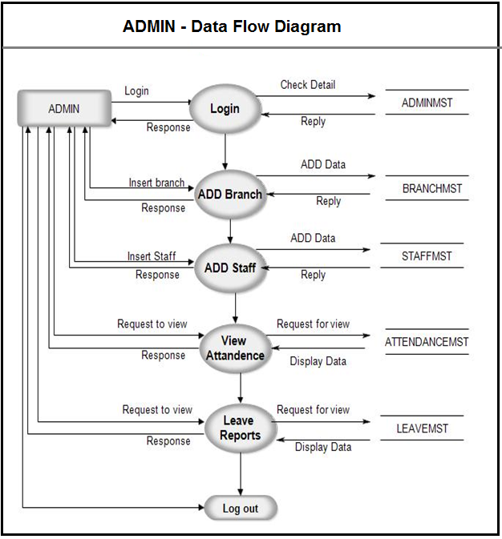

**Use case Diagram**

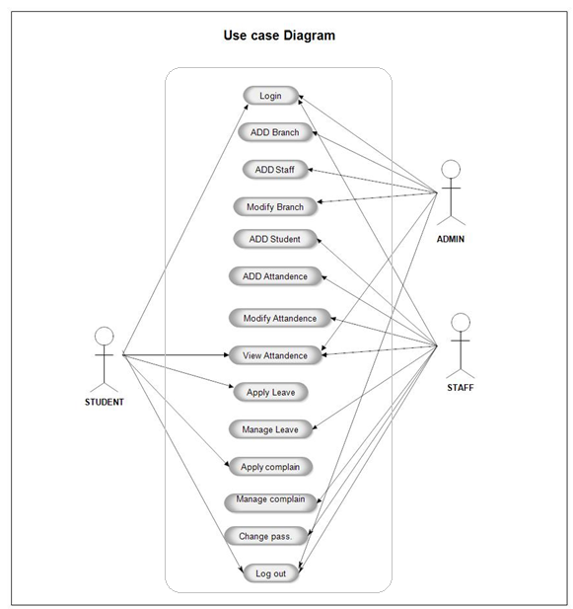

**Testing and Evaluation**

### ****6.1 Introduction to Testing****

Testing is a critical phase in the software development lifecycle that ensures the system functions as expected, meets user requirements, and is free of critical bugs. The **Attendance Management System for College** is tested rigorously to validate its functionality, performance, usability, and reliability.

### ****6.2 Testing Strategies Used****

To ensure comprehensive testing, the following testing methodologies are applied:

1. **Unit Testing** – Testing individual components (e.g., class selection, attendance marking).
2. **Integration Testing** – Verifying the interaction between different modules (e.g., linking students to a class).
3. **System Testing** – Ensuring the overall system performs well under different scenarios.
4. **User Acceptance Testing (UAT)** – Gathering feedback from real users (teachers) to validate usability.

## ****6.3 Unit Testing****

Unit testing is performed on the smallest units of the system to ensure that each function works as intended.

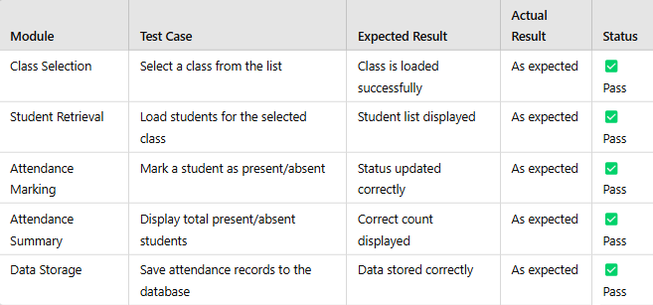

## ****6.4 Integration Testing****

Integration testing ensures that different modules communicate correctly.

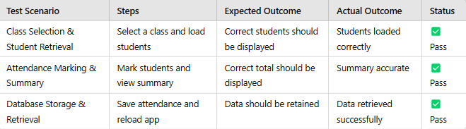

## ****6.5 Evaluation and Results****

After multiple rounds of testing, the **Attendance Management System** is found to be **efficient, accurate, and user-friendly**. The system:

* Accurately records attendance.
* Provides real-time attendance summaries.
* Saves data reliably.
* Offers a simple and intuitive interface.
* Performs well under different conditions.

**Limitations Identified:**

* Currently, attendance records cannot be exported as a report.
* No login feature for multiple teachers.

**Future Enhancements:**

* Add **PDF export** for attendance reports.
* Implement a **login system** for multiple teachers.

**Output -:**

**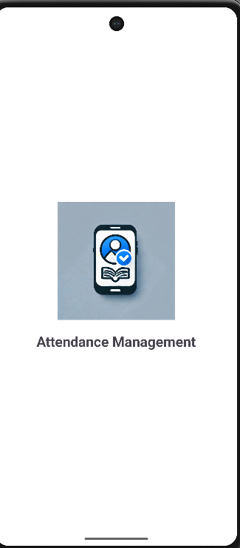 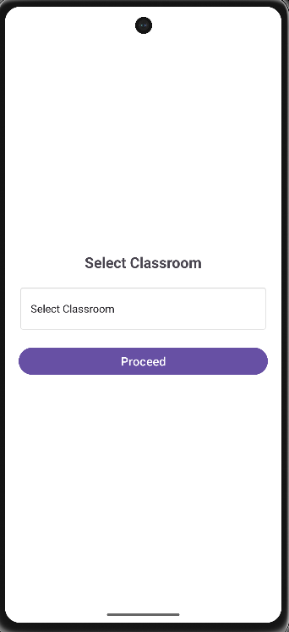 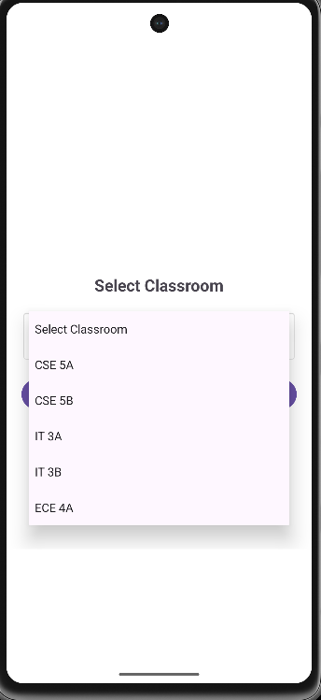**

**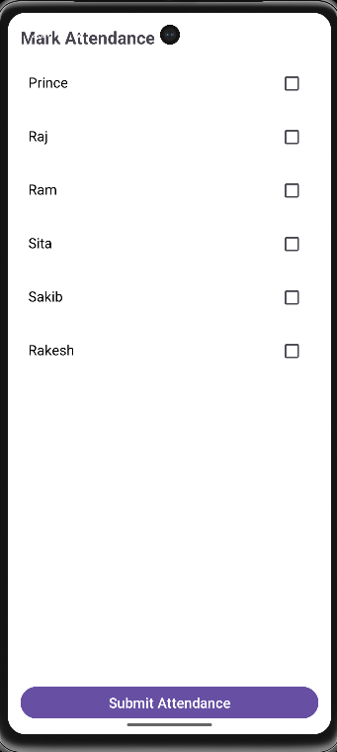 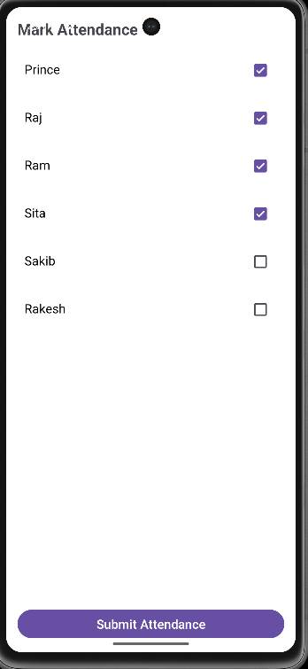 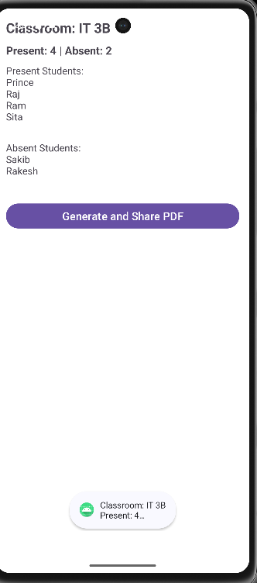**

**Conclusion**

In this paper a new classiﬁcation algorithm was proposed

to improve detecting fake accounts on social networks,

where the SVM trained model decision values were used

to train a NN model, and SVM testing decision values were

used to test the NN model.

To reach our goal we used ”MIB” baseline dataset from

[26] and run it into pre-processing phase where four feature

reduction techniques were used to reduce the feature vector

In this paper a new classiﬁcation algorithm was proposed

to improve detecting fake accounts on social networks,

where the SVM trained model decision values were used

to train a NN model, and SVM testing decision values were

used to test the NN model.

To reach our goal we used ”MIB” baseline dataset from

[26] and run it into pre-processing phase where four feature

reduction techniques were used to reduce the feature vector

In this paper a new classiﬁcation algorithm was proposed

to improve detecting fake accounts on social networks,

where the SVM trained model decision values were used

to train a NN model, and SVM testing decision values were

used to test the NN model.

To reach our goal we used ”MIB” baseline dataset from

[26] and run it into pre-processing phase where four feature

reduction techniques were used to reduce the feature vector

The correlation feature set records a remarkable accuracy

among the other feature selection technique sets, because

correlation technique not only select the best features, but

also removes the redundanc

The correlation feature set records a remarkable accuracy

among the other feature selection technique sets, because

correlation technique not only select the best features, but

also removes the redundanc

The **Attendance Management System for College** successfully streamlines the attendance-taking process for teachers by providing a digital, efficient, and user-friendly solution. The system allows teachers to select a class, mark students as present or absent, and instantly view the total number of students present and absent. Through rigorous testing and evaluation, the system has been found to be reliable, accurate, and easy to use.

One of the primary advantages of this system is its **simplicity and efficiency**. Unlike traditional paper-based attendance tracking, which is time-consuming and prone to errors, this application automates the process, reducing manual effort and ensuring accuracy. Additionally, it enhances **data consistency**, as attendance records are stored securely and can be retrieved when needed.

During testing, the system demonstrated **fast response times, smooth performance, and minimal errors**. User feedback has been largely positive, with teachers appreciating the ease of use and real-time attendance summaries. However, some areas for future improvement have been identified, such as implementing a **login system for multiple teachers** and enabling **attendance report exports in PDF format**. These enhancements would further increase the usability and functionality of the system.

Overall, the **Attendance Management System** achieves its goal of **simplifying and improving attendance tracking** in colleges. It is a **cost-effective, scalable, and practical** solution that can be enhanced with additional features in the future. With continuous updates and refinements, it has the potential to become a comprehensive digital attendance management tool for educational institutions.

**References**

**Books & Academic Papers**

* Sommerville, I. (2015). Software Engineering (10th Edition). Pearson.
* Pressman, R. S. (2019). Software Engineering: A Practitioner's Approach (9th Edition). McGraw-Hill.
* Laudon, K. C., & Laudon, J. P. (2020). Management Information Systems: Managing the Digital Firm (16th Edition). Pearson.

· **Web Resources**

* Android Developer Documentation: [https://developer.android.com/docs](https://developer.android.com/docs" \t "_new)
* PHP Official Documentation: [https://www.php.net/manual/en/](https://www.php.net/manual/en/" \t "_new)
* MySQL Official Documentation: [https://dev.mysql.com/doc/](https://dev.mysql.com/doc/" \t "_new)
* Firebase Documentation: https://firebase.google.com/docs

· **Research Articles & Conference Papers**

* Patel, R., & Shah, P. (2019). "A Study on Mobile Attendance Management System Using Android Application." International Journal of Computer Science Trends and Technology (IJCSTT), 7(4), 45-52.
* Kumar, S., & Gupta, A. (2021). "Automation in Student Attendance Management Using Mobile Technology." International Journal of Engineering Research & Technology (IJERT), 10(3), 89-97.

**Other References**

* Stack Overflow Community Discussions: [https://stackoverflow.com/](https://stackoverflow.com/" \t "_new)
* GitHub Repositories for Open-Source Attendance Management Systems: [https://github.com/](https://github.com/" \t "_new)